## Introduction and Data Analysis

Saharan scientists had measured the drooled saliva of a singular camel in an effort to quantify the fluid loss of a camel throughout the Saharan day. Table 1, “*Measurements of the amount of fluid drooled by a camel as a function of time,*” shows that each measurement was taken, with negligible uncertainty, in 0.1 hour (6 minute) intervals, up to a total time of 1.4 hours (84 minutes). The 1 hour interval was missed due to unforeseen circumstances. Through linear regression analysis, the value of this missed data point was determined to be approximately 65mL of fluid loss at one hour of time elapsed.

The following figures show the plotted data, with a linearly regressed line of best fit. Error bars corresponding to the respective uncertainty of each test were plotted on the data points, with the gradient and intercept (and their respective uncertainties) overlaid on the graph.

|  |  |
| --- | --- |
|  |  |
| **Figure 1: Camel Salivation over Time (Absolute Error)** | **Figure 2: Camel Salivation over Time (Relative Error)** |
| Relationship between Camel Salivation (measured in millilitres of fluid loss) and time (measured in hours). Uncertainty was found to be ±5mL of each measurement, with the error seen to be constant across measurements. | Relationship between Camel Salivation (measured in millilitres of fluid loss) and time (measured in hours). Uncertainty was found to be ±5% of each measurement, with the relative error seen to be increasing with the size of the measurement. |

Linear regression was chosen as the preferred method of analysis due to the simplicity of calculation and clearly linear nature of the data. The line of best fit was weighted across both figures in relation to the uncertainty in measurement. Figure 2 shows the line parameters with much less error of up to a factor of ten times more accurate than that of Figure 1. This was determined to be due to the error being relative to measurement size, meaning that as the time approached zero (or the beginning of the measurements being taken), the data was vastly more accurate which lead to a reduction in the range of possible y-intercepts.

The above figures account for loss of fluid only due to salivation although in practicality, other factors contribute to the fluid loss of a camel such as the camels perspiration. Accounting for this, it was shown that total fluid loss of a camel over the length of a day of sunlight is $(11±2)×10^{2}$ mL (Appendix 4). This value was calculated with an obtained rate of 25±2mL fluid loss per hour due to perspiration, a rate of 65±0.2mL fluid loss and hour as a result of salivation, and a 12±2 hour day in the Sahara desert.

In conclusion, linear regression is a powerful calculation tool that aids in the extrapolation of further data and forms the basis of a more thorough analysis. Given a basic set of data, it was determined that the observed camel drooled, on average, 65±0.2mL of saliva every hour during the specified period. This value contributed to the calculated total of $(11±2)×10^{2}$ mL of fluid loss during the period of sunlight in the Saharan day, which took into account additional fluid loss as a result of perspiration.

## 

## Appendices:

### Appendix 1: MATLAB Script for plotting data with linear regression line of best fit

|  |
| --- |
| %define variables and basic calculations xvar = [0.1 0.2 0.3 0.4 0.5 0.6 0.7 0.8 0.9 1.1 1.2 1.3 1.4]; yvar = [7 14 20 26 33 40 46 52 59 72 78 85 91]; y_uncertain = 0.05 * yvar; total_yvar = sum(yvar); ave_xvar = mean(xvar); ave_yvar = mean(yvar);  %check if uncertainty in y is an array (uncertainty is a percentage of each value) [c, y] = size(y_uncertain); if (c > 1) || (y > 1)  isarray = 1; else   isarray = 0; end   %plot basic graph plot(xvar, yvar, 'x'); hold on; axis([0 1.5 0 100]); xlabel('Time (hrs)'); ylabel('Fluid (mL)'); title('Camel Salivation over Time');  if isarray == 1  errorbar(xvar, yvar, y_uncertain, 'LineStyle', 'none'); else   error = ones(size(yvar)) * y_uncertain;  errorbar(xvar, yvar, error, 'LineStyle', 'none'); end   %calculate trendline parameters tot_wx = 0; tot_wy = 0; tot_weight = 0; for i = 1:length(xvar)  if isarray == 0  weights = 1 /(y_uncertain .^2);  else  weights = 1 /(y_uncertain(i) .^2);  end  val_wx = (weights) * xvar(i);  val_wy = (weights) * yvar(i);  tot_weight = tot_weight + (weights);  tot_wx = tot_wx + val_wx;  tot_wy = tot_wy + val_wy; end  ave_wx = tot_wx / tot_weight; ave_wy = tot_wy / tot_weight; weight_diff = 0; tot_weight_xdiff_y = 0;  for i = 1:length(xvar)  if isarray == 0  weights = 1 /(y_uncertain .^2);  else  weights = 1 /(y_uncertain(i) .^2);  end  diff = xvar(i) - ave_wx;  weight_diff = weight_diff + (weights * (diff .^ 2));  weight_xdiff_y = weights * (xvar(i) - ave_wx) * yvar(i);  tot_weight_xdiff_y = tot_weight_xdiff_y + weight_xdiff_y; end  gradient = (1/weight_diff) * tot_weight_xdiff_y; int = ave_wy - (gradient * ave_wx);  %calculate gradient and intercept uncertainties tot_di = 0; tot_weight_di = 0; for i = 1:length(xvar)  di = yvar(i) - (gradient * xvar(i)) - int;  tot_di = tot_di + di;  weight_di = weights * (di .^ 2);  tot_weight_di = tot_weight_di + weight_di; end   gradient_uncertainty = sqrt((1 / weight_diff) * (tot_weight_di / (length(xvar) - 2))); int_uncertainty = sqrt(((1 / tot_weight) + ((ave_wx .^ 2) / weight_diff))) * (tot_weight_di / (length(xvar) - 2));  %define trendline bounds, then plot trendline with comments trendy_start = (gradient * xvar(1)) + int; trendy_end = (gradient * xvar(length(xvar))) + int; trendy = [trendy_start trendy_end]; trendx = [xvar(1) xvar(length(xvar))]; plot(trendx, trendy); text(0.2, 80, ['Intercept: ' num2str(int, 2) '±' num2str(int_uncertainty, 2) 'mL']); text(0.2, 70, ['Gradient: ' num2str(gradient, 2) '±' num2str(gradient_uncertainty, 2) 'mL per hour']); |

When uncertainty is 5mL, y_uncertain = 5. When uncertainty is 5% of the y value, y_uncertain = 0.05 * yvar.

### 

### Appendix 2: Camel Salivation Data

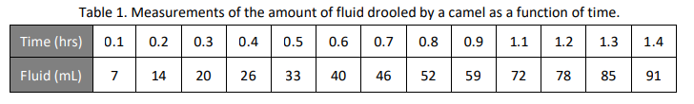

### Appendix 3: Uncertainty Propagation Formulae

#### Table 2: Summary of rules for combining independent and statistical uncertainties

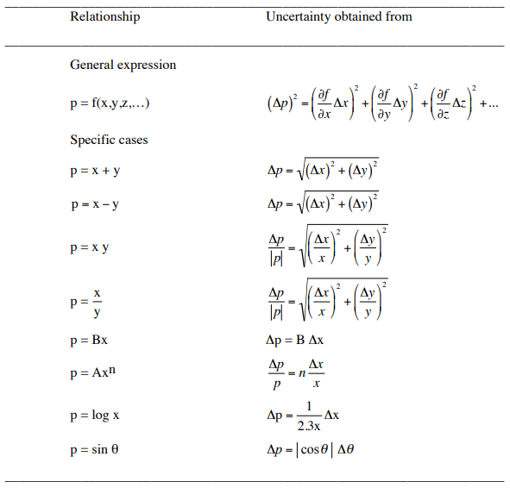

### Appendix 4: Uncertainty Propagation and Total Fluid Loss Calculations

Drooling rate (from task two) = d = (65±0.2)mL/hour

Perspiration rate = p = (25±2)mL/hour

Day length = t = (12±2) hours

Let the amount of fluid lost in a day be represented by character F, measured in mL:

$F =t(d+p)$

Substituting in the values gives:

$F =12×(65+25)$

$F =12×(90)$

$F =1080$

Accounting for the 2 significant figures given in the original values,

$F ≈1.1×10^{3}$

Therefore, there is an expected 1100mL of fluid lost every day for a camel in the Sahara.

Using Table 2 (Appendix 3), the uncertainty for this fluid loss is propagated. Firstly, for the term (d+p),

$Δ(d+p) = \sqrt{(Δd)^{2}+(Δp)^{2}}$

$Δ(d+p) = \sqrt{(0.2)^{2}+(2)^{2}}$

$Δ(d+p) = \sqrt{0.04+4}$

$Δ(d+p) =2.09$

This value for $Δ(d+p)$ rounds up to 2.1. Since each of the original uncertainties was given with one significant figure, this propagated uncertainty must remain at one significant figure. Thus, $Δ(d+p) ≈2$

Now for the term $t(d+p)$:

$Δt(d+p) =ΔF$

$ΔF = |F|⋅\sqrt{(\frac{Δ(d+p)}{(d+p)})^{2 }+(\frac{Δt}{t})^{2}}$

$ΔF = |1100|⋅\sqrt{(\frac{2}{90})^{2 }+(\frac{2}{12})^{2}}$

$ΔF = 1100⋅\sqrt{0.00049+0.0278}$

$ΔF = 1100⋅0.1682$

$ΔF = 185.02$

Accounting for the one significant figure given for each of the uncertainties,

$ΔF ≈ 2×10^{2}$

Therefore, the amount of fluid lost in a day may be given by

$F =(11±2)×10^{2} mL$